

**CANADIAN SCULLING MARATHON**

**20th Anniversary**

***Full (42k) and Half (21k) – Sunday, August 24, 2025 – Ottawa, Ontario***

Welcome to the Canadian Sculling Marathon (CSM) organized by the Ottawa New Edinburgh Club (ONEC Rowing) and inspired by the world-renowned Canadian Ski Marathon with emphasis on participation, fitness, endurance, and fun. ONEC partners with the Ontario Adventure Rowing Association (OAR) for this event. The CSM was first run in 2005; so this is the 20th anniversary.

The CSM offers a choice of two touring distances, the full marathon (42 km) and the half marathon (21 km). The scenery along both routes is as spectacular as it is varied: views of the capital’s most famous landmarks, shoreline recreational pathways, and protected wetlands and forested areas.

Due to the potential windy and wavy nature of the route, the Marathon is only open to stable touring / coastal / open water boats. The following boats are permitted in both marathons:

|  |  |
| --- | --- |
| ***Singles*** | *Touring singles: e.g., Hudson T-6, Alden Star, Echo Sport/Classic/Islander*  *Coastal boat singles: e.g., Eurodifusion, Philippi*  *Stable open water singles 1: e.g., Maas 24/21, Wintech Explorer 24/21, Alden Star/18/16/Quest/Martin, , Rossiter Laser 18/Louden, Whitehall.*  *-----------------------------------------------------------------------------------------------------------------------------------------------------------------------------------------------------------------------------------------------------------------------------------------------------*  *1 the beam at the waterline must be at least 14 inches to ensure stability in rough waves.* |
| ***Doubles*** | *Touring doubles: e.g., Hudson T-7, Swift Touring Gig 2+*  *Coastal boat doubles: e.g., RSB (Eurodifusion), Philippi; Liteboat, Swift*  *Stable open water doubles: e.g., Alden 18, Maas Ocean, Wintech 30, Alden Star, Ocean Shell,*  *Whitehall* |
| ***Quads*** | *Touring coxed quads: e.g., Hudson T-11, Wintech Odyssey, Swift Touring Gig 4+, Liteboat Touring*  *Coastal quads: e.g, RSB (Eurodifusion), Philippi, Swift Coastal* |

There is an option to rent touring quads and doubles (see Captain’s registration form on OAR website).

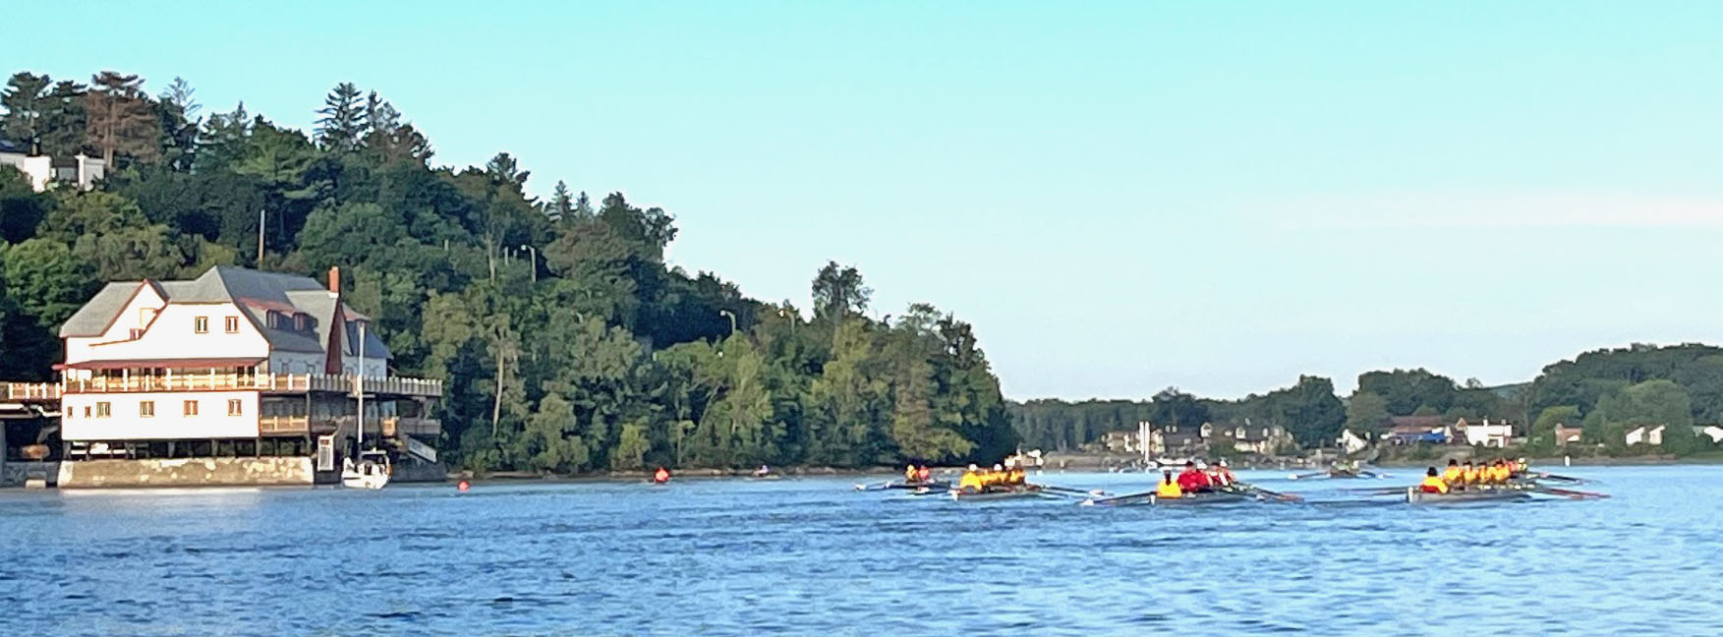

**Tentative Schedule**

**Saturday, August 23, 4-7 pm**

Welcome! ONEC’s address is 501-504 Sir George-Étienne Cartier Parkway, Ottawa. Facilities are split between the waterfront facilities at the River House and the tennis courts on the land side. Please park your car in the circle area to the east of the tennis courts. Participants must check-in and pick up their CSM package (T-shirt, map, boat markers) at the registration desk. More information will be sent to participants as to where the rigging and launching will occur.

The captain’s meeting happens on Saturday at 6:00 pm beside the registration desk.

**Sunday, August 24, Sculling Marathon**

ONEC waterfront facilities, 504 Sir George-Étienne Cartier Parkway, Ottawa. Please park in the circle area to the east of the tennis courts and walk down to the waterfront facilities in the River House. If you have not done so, pick up your package at the registration desk. Please aim to be here at least 45 minutes before the start, so everyone could be on the water at least 10 minutes before the start time.

|  |  |  |
| --- | --- | --- |
|  | **Full Marathon** – 42 km | **Half Marathon** – 21 km |
| Arrival | 5:45 am | 7:45 am |
| On-water cut-off | 6:20 am | 8:20 am |
| Start time | 6:30 am | 8:30 am |
| Cut-off time | 5 hours elapsed rowing time  OR  12:00 noon | 2½ hours elapsed rowing time  OR  11:30 am |
| Refreshments (at waterfront) | Available when scullers finish event: 9:00 am to 12:00 | |
| BBQ (at tennis pavilion) | 11:30 | 11:30 |
| Medal ceremony | 12:30 pm | 12:30 am |

Participants should be in good physical condition and have rowed their target distance. You should be aware that you’ll be rowing some open stretches of the Ottawa River, where wind, waves and current can give rise to challenging conditions. Organizers reserve the right to change the routes in the event of adverse conditions.

In addition to rowing skills and endurance, navigation skills are required. Participants should familiarize themselves with the route map and attend the pre-marathon captain’s meeting where information will be given on potential hazards, which may include deadheads, buoys and powerboat traffic. ONEC safety boats will be on the water to help ensure your safety. Because of the nature of the course, all boats must carry Transport Canada mandated safety equipment: life jackets (one per individual), bailer, throw line and whistle.

Visible CSM jerseys are given as well as momentos to participants who meet the distance challenge.

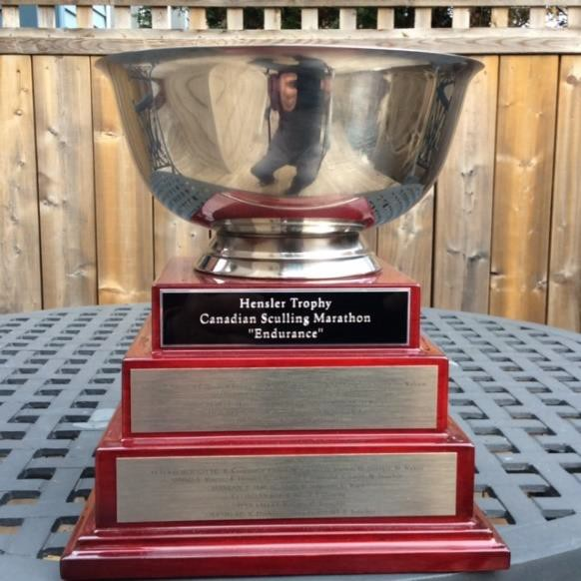

*The* ***Hensler “Endurance” Trophy*** will be awarded to the club with the most participants who complete the full marathon within the allocated time as predetermined by the CSM organizing committee. In recognition of the twentieth anniversary of the CSM in 2025 the successful club will receive a donation of

$2000. All participants who successfully complete the marathon within the prescribed time-frame will have their names and club affiliations engraved on the trophy.